14-Feb-17

****2/14/2017

Rohit Chauhan

EPITA ME-2018 (SDE)

**Identity Management Software**

**(Fundamental Java Project)**

Table of Contents

1. Subject description 2

2. Subject analysis 3

3. Conception 4

4. Console operations description 7

4.1 User Guide 7

User Login 7

Menu 8

Create an Identity 8

Modify an Identity 9

Delete an Identity 10

List Identities 11

5. Bibliography 12

# **Subject description**

The IAM Application is an Identity Management Application. The main goal is to manage users of Information System. The application is able to create an identity, modify the created identities and also delete the same. Summary of the activities which can be executed by the software are given below:

* Access, create and modify user information
* Persist users data in a database (or in an XML File)
* Be robust, capable of good performance

# **Subject analysis**

* 1. Major features
     + 1. Access, create, modify and delete user information
       2. Persist user’s personal data in a database
       3. Portable, Robust, efficient
       4. User friendly and simple interface
  2. Application Feasibility
     + 1. Strengths
          1. Simple Database Architecture
          2. Password Secured software
          3. Authentication dependent
       2. Weakness
          1. Security Management
          2. Too less detail of identities
          3. Different user identities (Normal, admin)
          4. Localized Database
  3. Data description
     + 1. IDENTITIES - It is the table which contains all the information related to the Identity. The details of the table are described below.
          1. Identity Display name: It contains the display name of the user.
          2. Identity Birthdate: It contains the birthdate of the

user.

* + - * 1. Identity Email: It contains the email address of the user.
        2. Identity ID: It is the primary key of the table which is linked to all the records.
      1. People: It is table which contains the names of the person having their user id in the system.
         1. Person - It contains the name of the user having a valid user id.
         2. Person ID – It is the primary key of the table which is linked with all the records.
      2. Only users and root have the privilege to update the database.
      3. It’s a well-designed program with an interactive menu.
  1. Expected results
     + 1. Users with administrative privileges can create, delete and modify identities.
       2. User provided information can be stored in database.
  2. Scope of the application (limits, evolutions)

1. Application can be used in every group hierarchical area.
2. Application can be used for other kind of identities (library management, small data management) and can be enhanced to store detailed information. It can be of good usage for banking process.

# **Conception**

* 1. Data structures
     1. *Array List* - An Array List is a dynamic data structure, meaning items can be added and removed from the list. A normal array in java is a static data structure, because you stuck with the initial size of your array. Array lists are created with an initial size. When this size is exceeded, the collection is automatically enlarged. When objects are removed, the array may be shrunk.
     2. *Token* - Tokens are the various Java program elements which are identified by the compiler. A token is the smallest element of a program that is meaningful to the compiler. Tokens supported in Java include keywords, variables, constants, special characters, operations etc.
  2. Global application flow

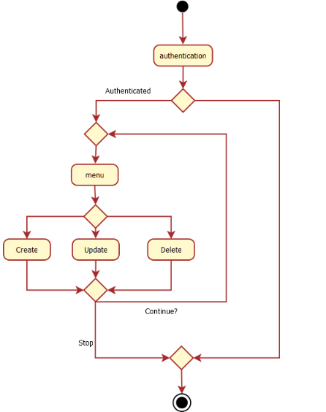

* 1. Global schema and major features schema

**C:\Users\Yasin\Downloads\Untitled Diagram.png**

# **Console operations description**

# User Guide

# User Login

When the application is started, the user is welcomed and prompted for the login details –



Once the login is entered, the user is then prompted for the password.

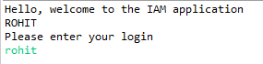

Once the password is entered and the details authenticated, the main menu is displayed.

In case of an invalid login, a warning would be displayed and the application would stop.

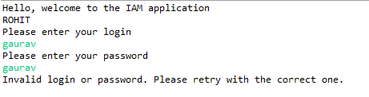

# Menu

The main menu is displayed and the user prompted to choose the action required.

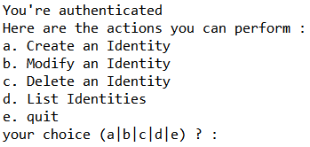

# Create an Identity

On entering choice as “a”, the user is prompted to enter the Identity display name as it is to be stored in the database.

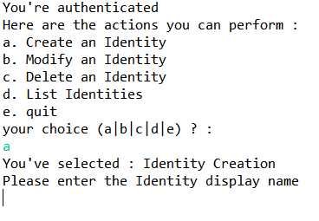

Once the Display Name is entered, the user is prompted to enter the Identity Email address –



Once the email is also provided, the identity is created and a message displayed on the screen to confirm that the identity has been successfully created.

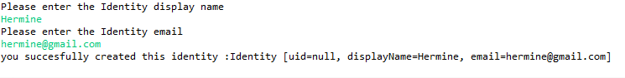

And the operations stops here. To execute another option, we must start the application again.

# Modify an Identity

Once the user login and password is authenticated, as above, the user must select the option “b”, if they want to modify an existing record, and the user will be prompted for the Identity Email of the Identity they want to modify.

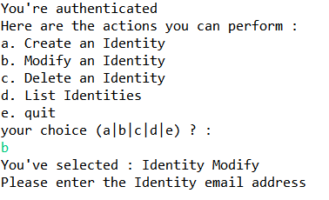

After the Identity email address is entered, the user is prompted for the Identity name as it was recorded earlier. If the incorrect name is given, a warning will be displayed and the execution will stop.

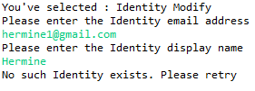

If the correct Identity name is entered, the user is then prompted to enter the new Identity Display Name and the new Identity Email address, allowing one to change one or both, as required.

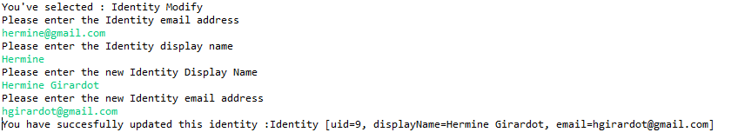

# Delete an Identity

To delete an identity, the user must choose option “c” from the main menu. The user is then prompted for the Identity email and Identity name to identify the record to be deleted –

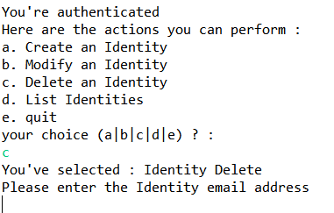

Once the correct Identity Email and Name are provided, the record is deleted.

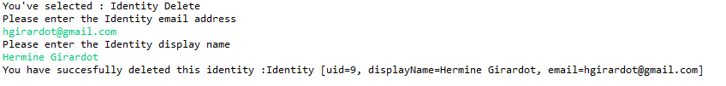

# List Identities

To view a list of all the identities in the database, the user must select option “d” and press “Enter”. This would list all the identities in the database.

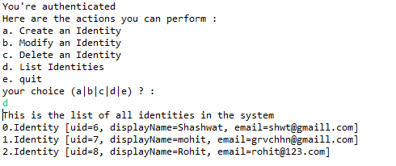

# Quit

To quit the application, the user must select option “e” and press “Enter”. This would get the user out of the application.

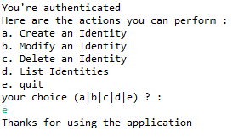

# **Bibliography**

**Websites:**

* <http://thomas-broussard.fr/work/java/courses/project/fundamental.xhtml>
* <http://google.com>
* <http://oracle.com>
* <https://eclipse.org/>
* <http://github.com>
* http://youtube.com

**Books Referred**

* Head First Java, 2nd Edition